1. What is software? What is software engineering?

Software is a set of instructions that tells to a computer what to do. Software is that part of a computer which cannot be touched.

…Software engineering is a technique through which we can developed or created software for computer system and any other electronic devices.



1. Explain types of software.

Application Software : Application software are designed to accomplish tasks for specific purposes. Ex .(MS-Office, Goggle chrome etc.)

System Software: System software are mainly designed for managing system resources.

Ex.(Windows operating system)

Driver Software : Driver software is also known as device drivers, are programs that allow your computer operating system to communicate with hardware devices.

Ex. Audio, Video, Printers

Middle ware Software :

Programming Software : programming software also known as development software as development software is a type of software that allows users to create, write test software programs.

Ex. (Visual Studio)

1. What is SDLC? Explain each phase of SDLC

Software Development life cycle.

It is also known as Software Development process.

SDLC is consists of the following stage

1.Planing

2.Analysis designing

3.Implementation

4.Testing

5.Maintains websites

1. What is DFD? Create a DFD diagram on Flipkart.

Data flow diagram

DFD is used in software development

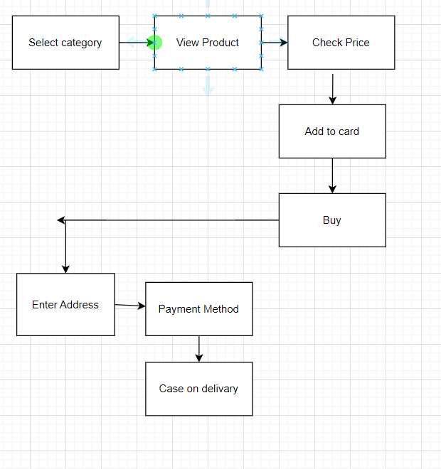

1. What is Flow chart? Create a flowchart to make addition of two numbers.

Flow chart is used to design some symbol or notation.

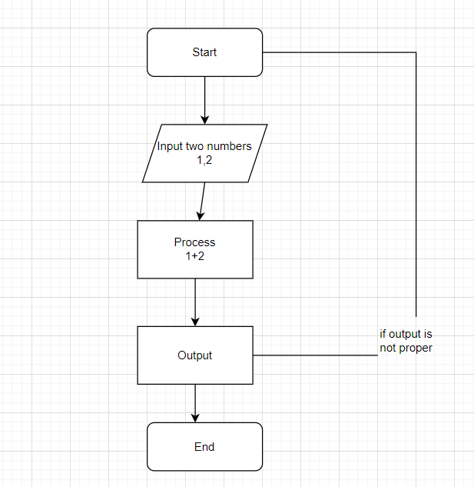

1. What is Use case Diagram? Create a use-case on bill payment in paytm.

Use-case diagram is a graphical representation of a system functional requirments showing how user communicate with system

